**Python Day1 Assignment:**

1. Write a Python program to get the smallest and largest number from a list of integers.

#defining the integer list  
myNewList = [-6, 5, 7, 9, 3]  
#looping through the list upto its maximum number of items  
for i in range(len(myNewList)):  
 #if the loop runs for the first time  
 if i==0:  
 #set the smallest and largest values to the first list item  
 smallest = myNewList[i]  
 largest = myNewList[i]  
 #if the looped number is smaller than the stored number store in smallest  
 if myNewList[i]<smallest:  
 smallest = myNewList[i]  
 # if the looped number is greater than the stored number store in largest  
 if myNewList[i]>largest:  
 largest= myNewList[i]  
  
print("The smallest number in the list is: ",smallest)  
print("The largest number in the list is: ",largest)

1. Write a Python program to get the following pattern using a nested loop.

**1**

**22**

**333**

**4444**

**55555**

**666666**

**7777777**

**88888888**

**999999999**

#define the range to 10 for 1 to 9  
for i in range(10):  
 #nested loop working till the new incremented outer loop number  
 for j in range(i):  
 #print the outer loop number number of times without a line break  
 print(i, end=' ')  
 #change the line after the number gets incremented  
 print('')

1. You are given a string and your task is to *swap cases*. In other words, convert all lowercase letters to uppercase letters and vice versa.

Example: Pythonist 2 → pYTHONIST 2

#define the string  
toConvert = "Pythonist 2"  
#use swapcase method to swap the case lower to upper and vise versa  
print(toConvert.swapcase())

1. Given a sentence use string split and join to get the result as shown below:

**Sample Input:** this is a string

**Sample Output:** this-is-a-string

#define the string  
myString = 'this is a string'  
#split the string by space in between them (stores in a list)  
splitString = myString.split(" ")  
#join the splitted string by a hyphen  
joinString = '-'.join(splitString)  
#print the final output  
print(joinString)

1. Write a Python program to find the difference between consecutive numbers in a given list.

Original list: [4, 5, 8, 9, 6, 10]

Difference between consecutive numbers of the said list: [1, 3, 1, -3, 4]

#define the list  
numList = [4, 5, 8, 9, 6, 10]  
#get the length of the list  
getRange = len(numList)  
#define an empty list to append later  
newList = []  
#loop through the list  
for i in range(getRange):  
 #check if it's last list element or not  
 if i+1 != getRange:  
 #store the current number  
 initial = numList[i]  
 #store the consecutive number  
 consecutive = numList[i+1]  
 else:  
 #if last element then break out of the loop  
 break;  
 #find the difference  
 difference = consecutive-initial  
 #append the difference to the new list  
 newList.append(difference)  
#print the new list  
print(newList)

1. Write a Python program to get the frequency of the elements in a given list of lists.

Original list of lists: [[1, 2, 3, 2], [4, 5, 6, 2], [7, 8, 9, 5]]

Frequency of the elements in the said list of lists:

{1: 1, 2: 3, 3: 1, 4: 1, 5: 2, 6: 1, 7: 1, 8: 1, 9: 1}

#define the list  
myListofList = [[1, 2, 3, 2], [4, 5, 6, 2], [7, 8, 9, 5]]  
#get into the sublist of the list  
myListofList = [n for sublist in myListofList for n in sublist]  
#define a dictionary  
showOccurence = {}  
#loop through the list  
for i in myListofList:  
 #store the number of times the number occurs  
 if i in showOccurence.keys():  
 showOccurence[i] += 1  
 else:  
 #set the key to the number  
 key = i  
 defaultVal = 1  
 #set default to 1  
 showOccurence[key] = defaultVal  
print(showOccurence)

1. Write a Python program to combine two lists into a dictionary, where the elements of the first one serve as the keys and the elements of the second one serve as the values. The values of the first list need to be unique and hashable.

**Sample Output:**

Original lists:

['a', 'b', 'c', 'd', 'e', 'f']

[1, 2, 3, 4, 5]

Combine the values of the said two lists into a dictionary:

{'a': 1, 'b': 2, 'c': 3, 'd': 4, 'e': 5}

#define the first list  
firstList = ['a', 'b', 'c', 'd', 'e', 'f']  
#define the second list  
secondList = [1, 2, 3, 4, 5]  
#zip the lists which results in creating a dictionary with keys and values respectively  
finalDict = dict(zip(firstList, secondList))  
#print the result  
print(finalDict)

1. Write a Python program to find the key of the maximum value in a dictionary.

Sample Output:

Original dictionary elements

{'Theodore': 19, 'Roxanne': 22, 'Mathew': 21, 'Betty': 20}

the maximum and minimum value of the said dictionary:

('Roxanne', 'Theodore')

#define the dictionary  
myValDict = {'Sagun': 19, 'SagunRupakheti': 22, 'Kathmandu': 21, 'Nepal': 20}  
#get the key of the maximum value by using the max function  
getKey = max(myValDict, key=myValDict.get)  
print(getKey)

1. Write a Python program to construct the following pattern, using a nested for loop.

**\***

**\* \***

**\* * \***

**\* * * \***

**\* * * * \***

**\* * * \***

**\* * \***

**\* \***

**\***

#define the range  
for i in range(0, 5):  
 #nested loop runs until 5 times  
 for j in range(0, i + 1):  
 # print the asterik with no space  
 print("* ", end="")  
 #change the line  
 print("\r")  
#do the same for reverse loop and order  
for i in reversed(range(0, 4)):  
 for j in range(0, i + 1):  
 print("* ", end="")  
 print("\r")

1. Write a Python program that prints all the numbers from 0 to 20 except the numbers in the given list [ 5, 6, 12, 15].

Note : use the ‘continue' statement.

#define the range  
for i in range(1,20+1):  
 #check if the numbers match from the list  
 if i in [5,6,12,15]:  
 #if so skip the numbers  
 continue  
 else:  
 #print the remaining numbers  
 print(i)

1. Write a Program to count the number of vowels in a given string.

Example:

Input_string = ‘Hello World’

Count_output = 3

#get the input string  
inputString = "Hello World Kathmandu"  
#define a counter  
getTotal = 0  
#loop through the string  
for x in inputString:  
 #check if contains a vowel  
 if x in ['a','e','i','o','u']:  
 #increment if contains vowel  
 getTotal+=1  
#print the total number of vowels  
print('The total number of vowels are:', getTotal)

1. Write a Python program to remove consecutive duplicates from a list.

**Original list:**

initial_input = [0, 0, 1, 2, 3, 4, 4, 5, 6, 6, 6, 7, 8, 9, 4, 4]

**After removing consecutive duplicates:**

final_output = [0, 1, 2, 3, 4, 5, 6, 7, 8, 9, 4]

#define the list  
numList = [0, 0, 1, 2, 3, 4, 4, 5, 6, 6, 6, 7, 8, 9, 4, 4]  
#get the length of the list  
getRange = len(numList)  
#define an empty list to append later  
newList = []  
#loop through the list  
for i in range(getRange):  
 #check if it's last list element or not  
 if i+1 == getRange:  
 #if last append directly  
 newList.append(numList[i])  
 break  
 #store the current number  
 initial = numList[i]  
 #store the consecutive number  
 consecutive = numList[i+1]  
 #if current and consecutive are same then skip  
 if initial==consecutive:  
 continue;  
 else:  
 #else append the number to the list  
 newList.append(initial)  
#print the new list  
print(newList)

1. Write a Program to read a sample text file and count the words having length greater than or equal to 5.

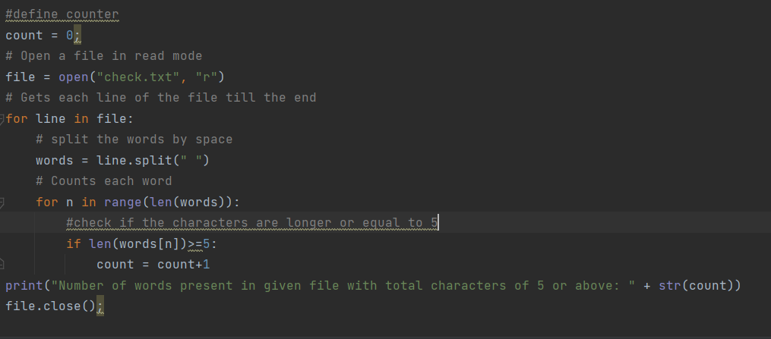

1. Write a program to read a sample text file and Capitalize the each word and append it to the same file.

# Open a file in read mode  
file = open("check.txt", "r")  
#open in append mode  
appfile = open("check.txt", "a")  
# Gets each line of the file till the end  
for line in file:  
 # split the words by space  
 words = line.split(" ")  
 # Counts each word  
 for n in range(len(words)):  
 #capitalize each word and append  
 appfile.write(words[n].capitalize())  
 appfile.write(' ')  
file.close()  
appfile.close()

1. Write a function in Python that takes a normal .txt file path as an input and counts the word in a given list **[ the, these, that, and]** and displays it.
2. #define counter  
   count = 0;  
   # Open a file in read mode  
   file = open("check.txt", "r")  
   # Gets each line of the file till the end  
   for line in file:  
    # split the words by space  
    words = line.split(" ")  
    # Counts each word  
    for n in range(len(words)):  
    #check if the words match  
    if words[n] in ['the','these','that','and']:  
    #increment the counter  
    count=count+1;  
   print("Number of words matchin the,these,that,and : " + str(count))  
   file.close();

1. Map, Filter, Reduce Question:  Given a list of strings fruits as shown below:

**fruits = ["Apple", "Banana", "Pear", "Apricot", "Orange"].**

1. Change each of the words to uppercase using map function

fruits = ["Apple", "Banana", "Pear", "Apricot", "Orange"]  
#change the case  
caseChanged = map(lambda x:x.upper(),fruits)  
print(list(caseChanged))

1. Filter out the words starting with ‘A’ using filter functionality

fruits = ["Apple", "Banana", "Pear", "Apricot", "Orange"]  
# using filter() + startswith() + lambda  
with_a = list(filter(lambda x: x.startswith('A'), fruits))  
print("The words starting with letter a : " + str(with_a))

1. Concat all words using reduce

fruits = ["Apple", "Banana", "Pear", "Apricot", "Orange"]  
#import functools module to use reduce  
import functools  
#import operator to use concat  
import operator  
#concat the list  
print(functools.reduce(operator.concat, fruits))